**Online bus reservation system**

**W3H :**

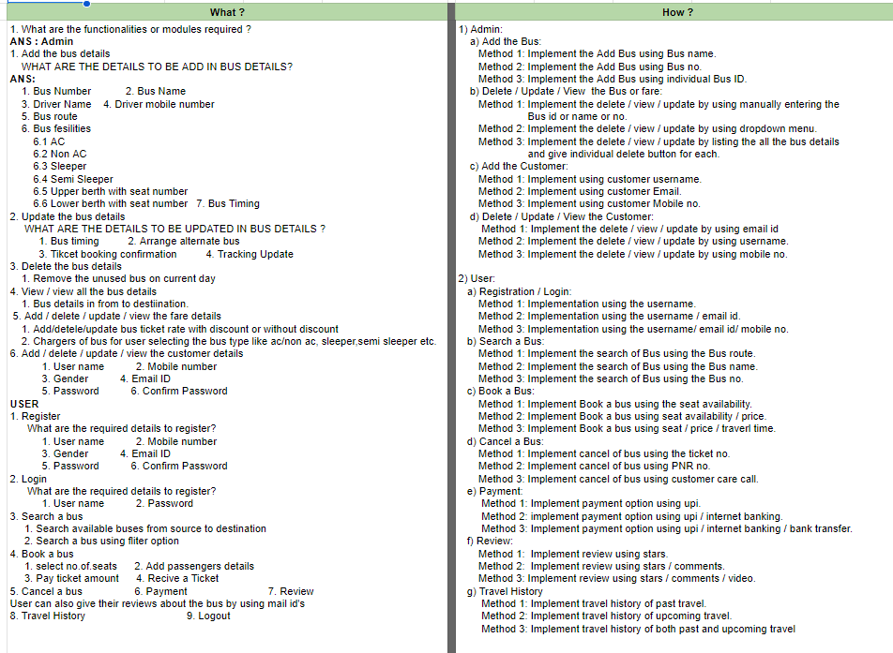

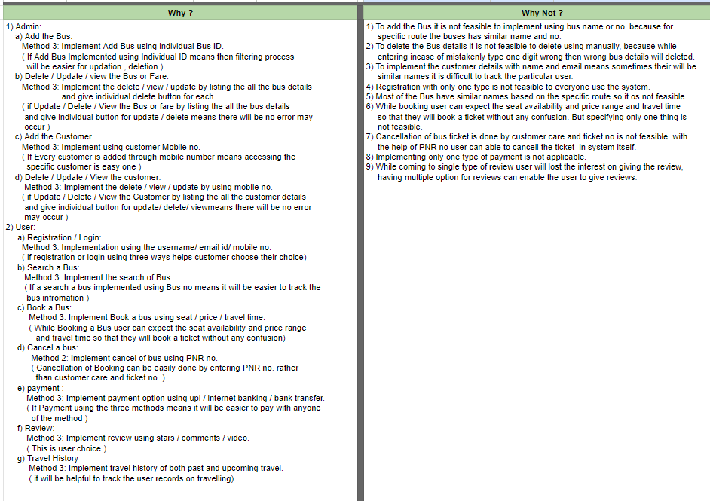

**Algorithm**

**ADMIN**

**Step 1:** Start

**Step 2:** Create an admin panel.

**Step 3 :**  Check whether the given admin details are valid or not ?, If not valid goto step 9

**Step 4:** if valid,thenVerify the bus documents

**Step 5:** Add the bus details, Delete the bus details, Update the bus details and View the details by using an individual bus id.

**Step 6:** Add the bus route, Update the bus route, Delete the bus route after adding bus details. **Step 7:**Admin can Add the customer details, Update the customer details, Delete the customer details .

**Step 8:** Add the driver and cleaner details, Update the driver and cleaner details, Delete the driver and cleaner details.

**Step 9:** Logout

**Step 10** : Stop

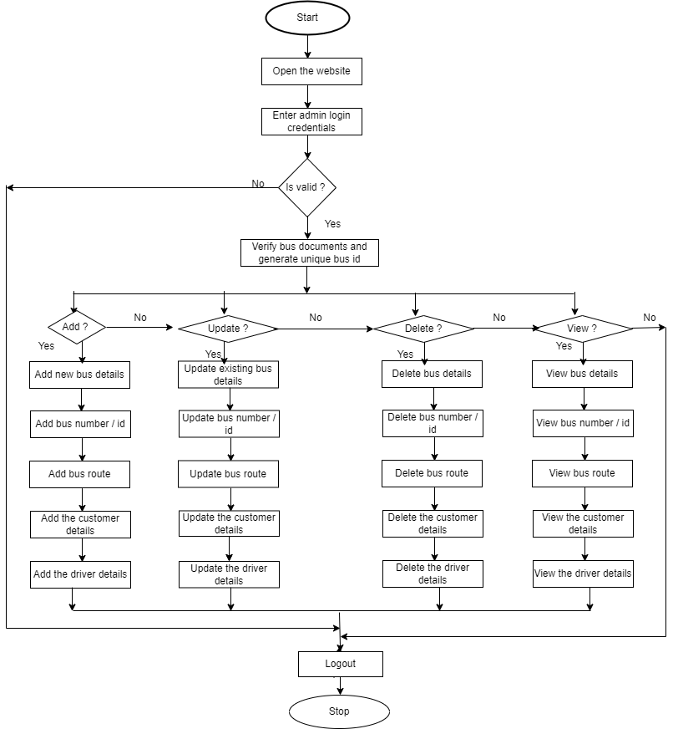

**User Algorithm**

**Step 1:** Start the Program.

**Step 2:** Open the website and users can register or login.

**Step 3:** If a new user, register the necessary details and go to step 4 else goto step 26.

**Step 4:** If an existing user, login to the website / app.

**Step 5**: If login credentials are not valid, then goto step27.

**Step 6:** Select the starting point of the travel.

**Step 7:**  If you found your starting place, then goto step 8. Else goto step 6.

**Step 8:**Select the destination.

**Step 9**: If you found your destination, then goto step 10. Else goto step 8.

**Step 10**: Select the no.of.seat.

**Step 11**: If a seat is available, then goto step12. Else goto step 10.

**Step 12 :** Select price range.

**Step 13:** If price is comfortable then goto step14 else goto step 12

**Step 14 :** Select the travel time

**Step 15 :** If is suitable foy yours then goto step 16, else goto step 14

**Step 16:** Enter passenger details.

**Step 17:** If you add more than 1 passenger details , then goto step

**Step 18:** Confirm your ticket.

**Step 19:** Pay the ticket amount through online.

**Step 20:**Receive the ticket from email & tickets are confirmed.

**Step 21**: Display “Tickets booked successfully”.

**Step 22:** If you want to cancel a ticket then goto step cancel a ticket , else goto step 23

**Step 23 :** You can review the bus as feedback

**Step 24 :** You can see your travel history.

**Step 25:** Logout the website/app.

**Step 26:** Display “invalid user and password try again” and goto step 28.

**Step 27:** Display “Enter correct details”

**Step 28**: Stop.

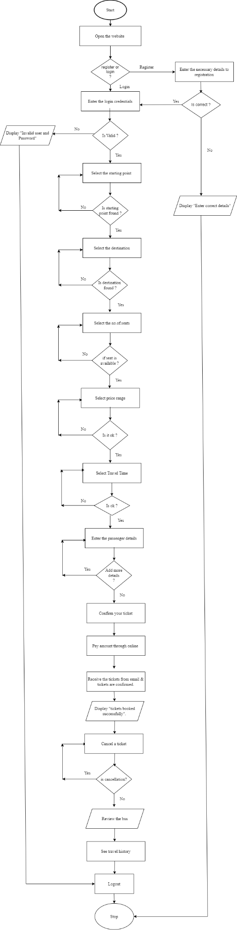

**UML**

**Class Diagram**

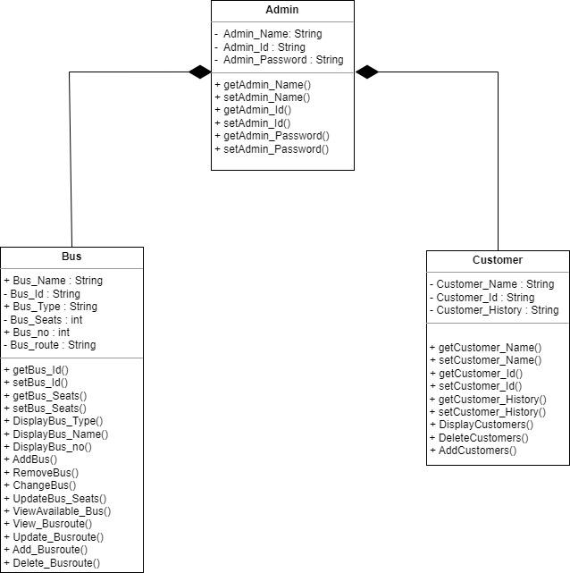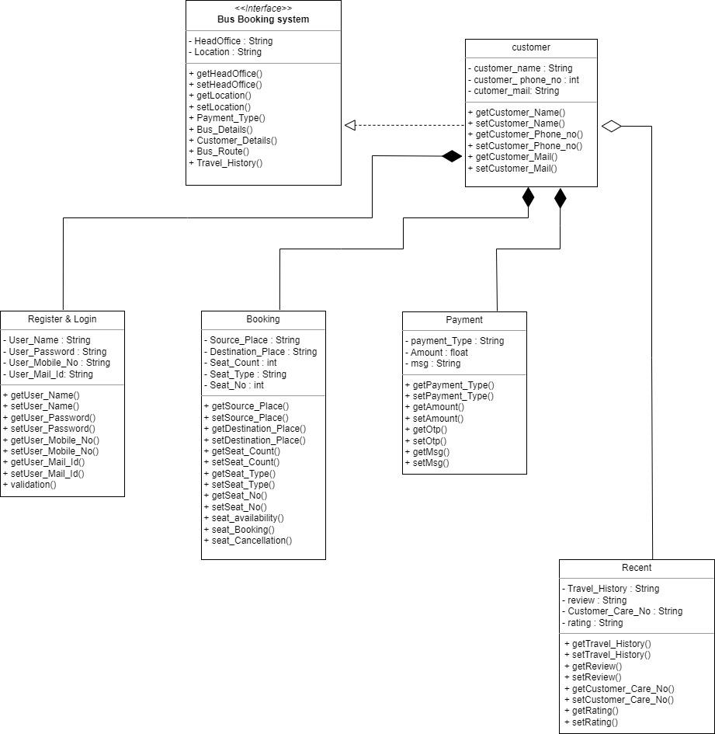

**Use Case Diagram**

**Admin:**

***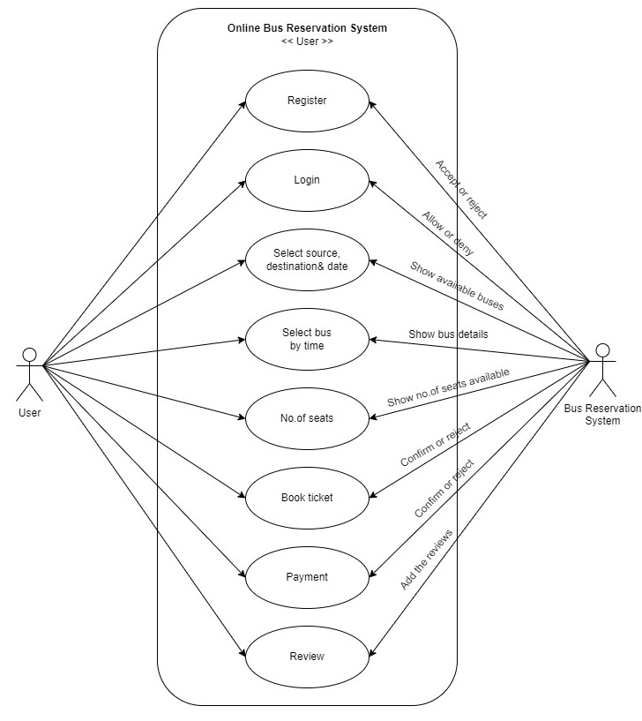*User:**

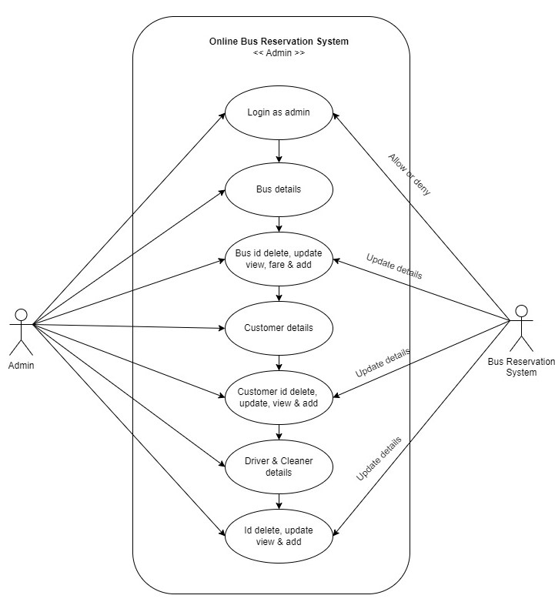***Sequence Diagram :***

***Register & Login***

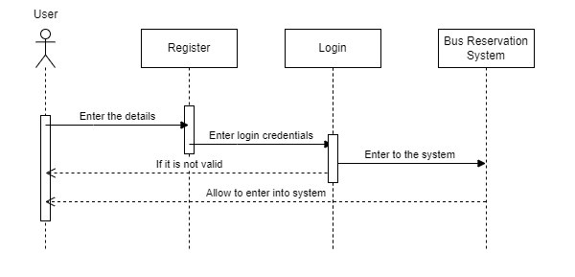

***Bus Fare :***

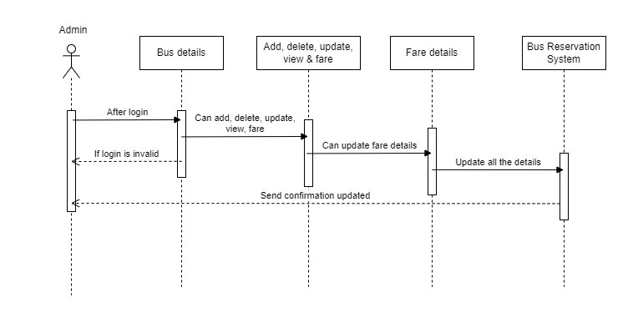

***Customer Details :***

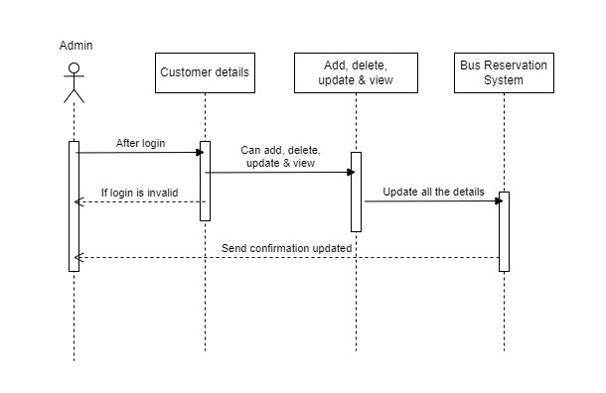

***Driver & Cleaner Details :***

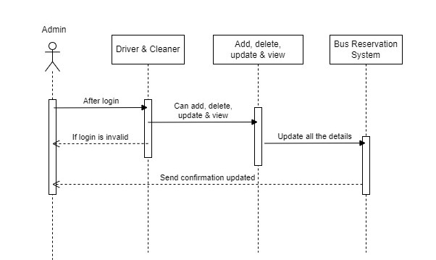

***Booking :***

